INSTALLING Zoom for Desktop (Windows)

Sign up for FREE at https://zoom.us/signup, and create a user name and password

To Download/Install Zoom:

You should be prompted to install Zoom when you join your first Zoom meeting. But you can always install it by following these steps:

- Go to the Zoom webpage: https://zoom.us/

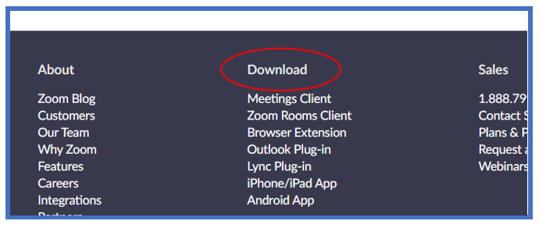
2. Scroll to the bottom of the page and click “Downloads”:

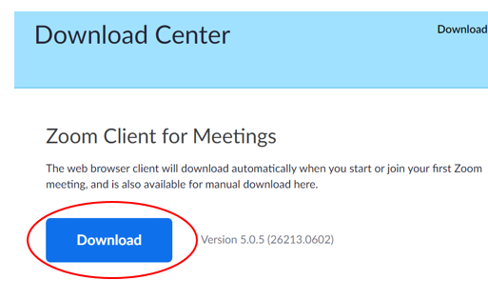
3. Click “Download” under “Zoom Client for Meetings”:

Once Zoom is installed, you can open it by clicking the Zoom icon on your desktop  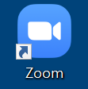 | You can also open it by clicking the Windows button on the bottom left of your desktop and scrolling down to “Zoom”  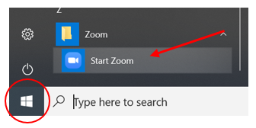

USING ZOOM ON COMPUTER

Joining a Meeting:

1. Sign in is not required if you want to join a meeting arranged by someone else. Select “Join a Meeting” and enter the meeting ID provided by the meeting organizer and your name. You can choose whether to turn off video or connect audio before you hit “Join”:

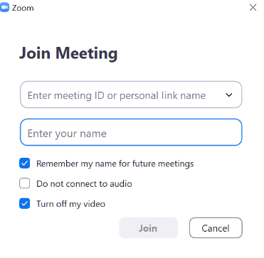
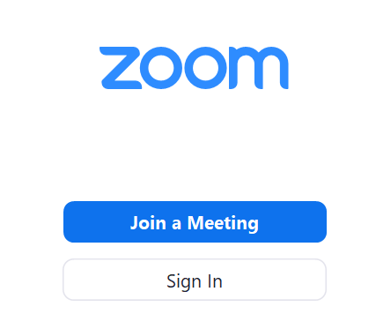

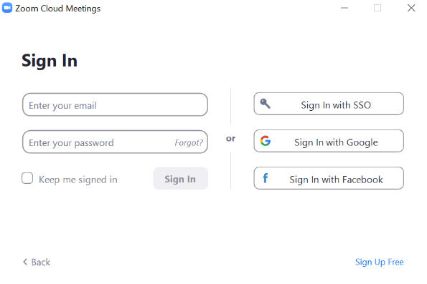
2. Or you can sign in using your email and password (or with Google or Facebook):

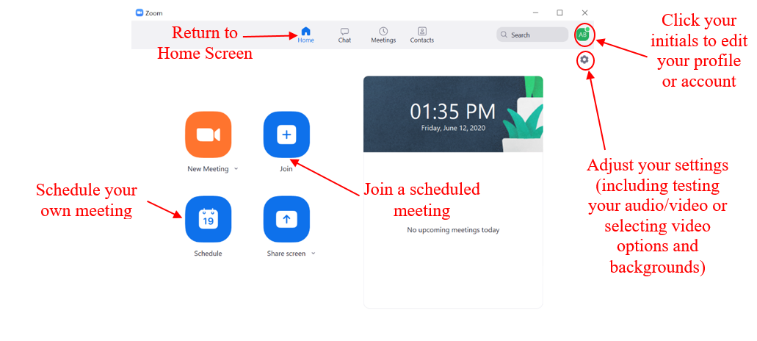
3. On your Home screen, you can select options, including:
4. When you are in a meeting, the bottom of the screen has your main tools:
Click “End” or “Leave Meeting” to exit the meeting

Opens the chat window, where you can chat with other participants

Click to mute and unmute your voice

Click to turn your camera on or off

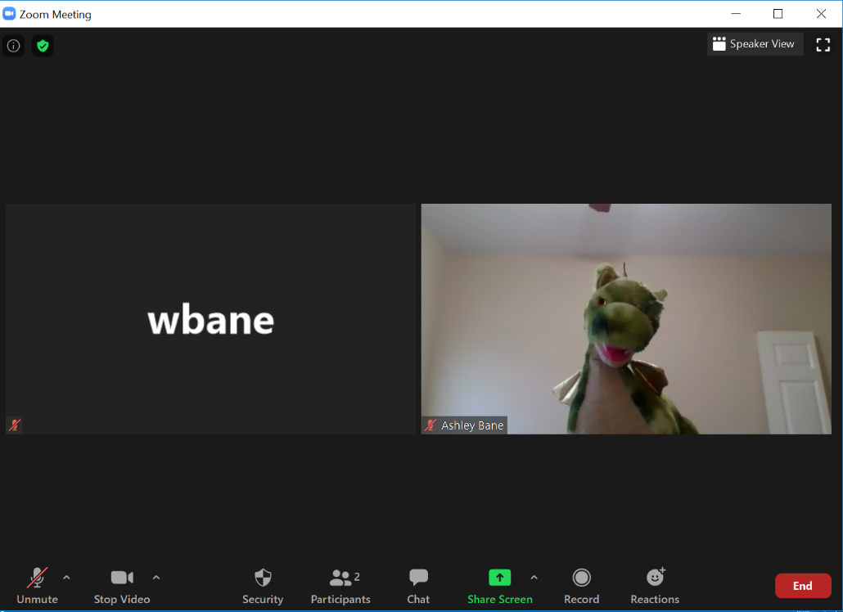
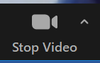
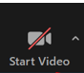
Click to change how you view the meeting on your screen– this does not change what other participants see
When there is no red line, and it says “Stop Video,” your camera is on and others can see you

When the red line is on “Start Video,” your camera is off and people can only see your name

