**INSTALLING Zoom for IPHONE**



1. Go to the App Store and search for “Zoom.”

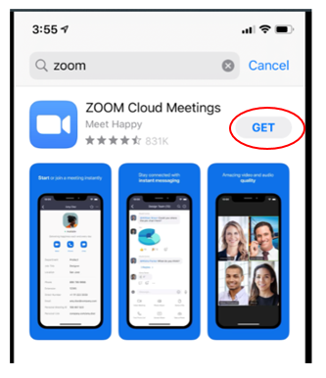

2. Choose ZOOM Cloud Meetings:

3. Once it is downloaded, click on

the Zoom app

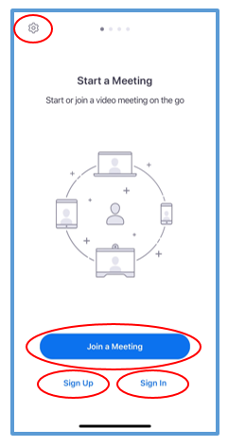

4. You can change your default settings (for example,

muting your microphone, turning off your video), here:

5. To join a meeting without signing in or signing up, click

“Join a Meeting.”

Enter the Meeting ID sent to you by the meeting organizer

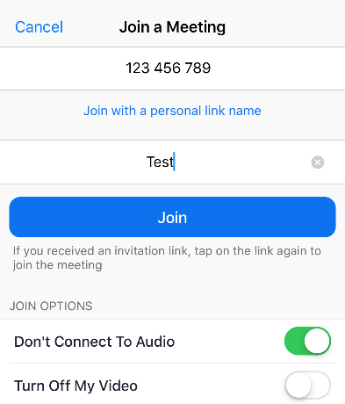and enter your name.

Select whether you want to connect to audio or turn off your video.

Hit “Join” to join the meeting.

|  |  |
| --- | --- |
| 6. To sign up for a free Zoom account, click “Sign Up,” and enter your email address and name: | 7. If you already have a Zoom account, or if you want to sign in using your Facebook or Google account, click “Sign In,” and log in: |

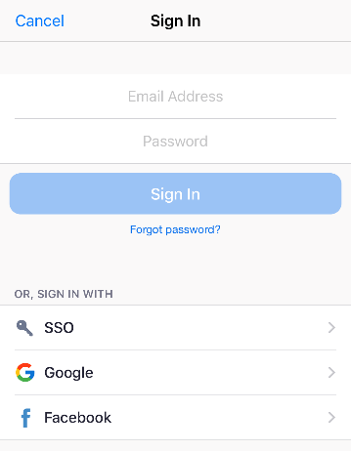

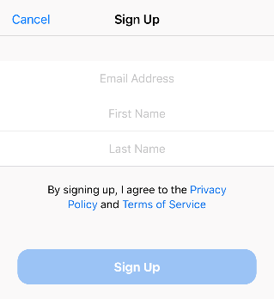

**USING ZOOM ON IPHONE**

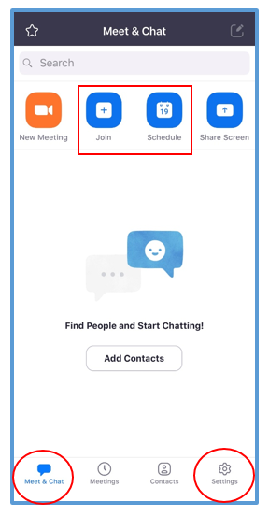

1. Once you sign in, your Zoom home screen will allow you to join a meeting or schedule a meeting.

You can also change your audio and video settings by clicking “Settings” in the bottom right corner.

You can always return to this home screen by clicking “Meet & Chat” in the bottom left corner.

2. Once you are in a meeting, you can turn your

microphone and camera on and off by using the buttons

at the bottom of the screen.

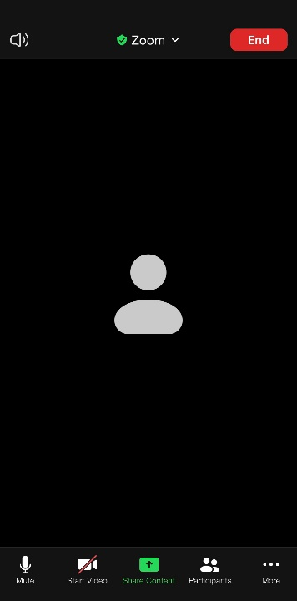

Click “Mute” to mute your voice

Click “Unmute” to speak

The red line means you are on mute, and participants cannot hear you:

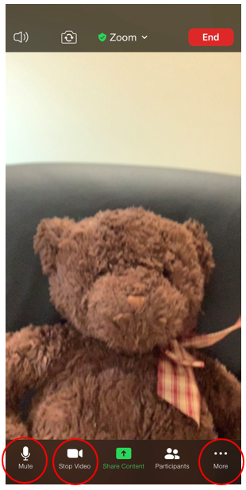



Click “More” to access the Chat feature, and chat with participants

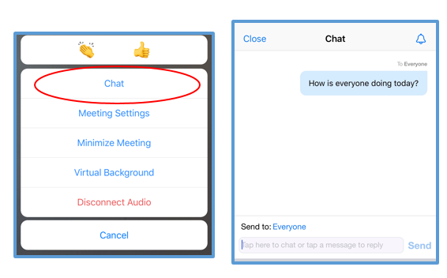

Click “Start Video” to

turn on your camera

Click “Stop Video” to turn off your camera